Presented by the RWC Ecological Stewardship Committee and the Cultural Enrichment Committee

Part of the RWC Writing 2017 Miniseries .
Marjorie Maddox
“National Poetry Month” - Poetry and Fiction Reading
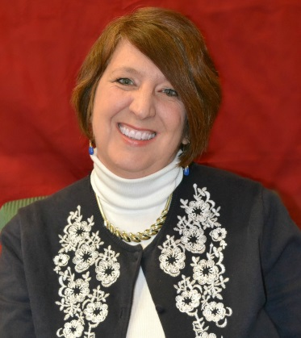  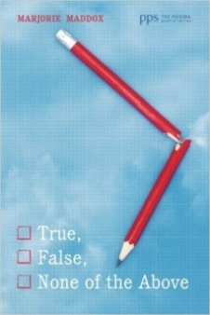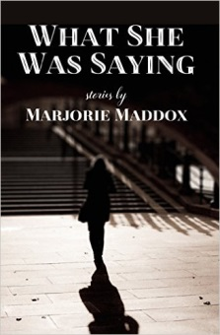 | Sage Graduate Fellow of Cornell University (MFA) and Professor of English and Creative Writing at Lock Haven University, Marjorie Maddox has published eleven collections of poetry—including True, False, None of the Above (Illumination Book Award Medalist); Local News from Someplace Else; Wives’ Tales; Transplant, Transport, Transubstantiation (Yellowglen Prize); and Perpendicular As I (Sandstone Book Award)—the short story collection What She Was Saying, and over 500 stories, essays, and poems in journals and anthologies.  Co-editor of Common Wealth: Contemporary Poets on Pennsylvania, she also has published the children’s books A Crossing of Zebras: Animal Packs in Poetry; Rules of the Game: Baseball Poems; A Man Named Branch: The True Story of Baseball's Great Experiment; and Inside Out: Poems on Writing Poems.  She is the great grandniece of Branch Rickey, the general manager of the Brooklyn Dodgers, who helped break the color barrier by signing Jackie Robinson.

Readings followed by Q&A and book signing

Friday, April 7 12:00 noon
Fireside Reading Room 235 in Golisano Library
Free admission – all are welcome to attend!
This event is sponsored by the RWC Cultural Enrichment Committee.
Contact Dr. Matthew Moore for further information by calling 585.594.6786 or e-mail moorem@roberts.edu.

